### Easter Egg Boxes

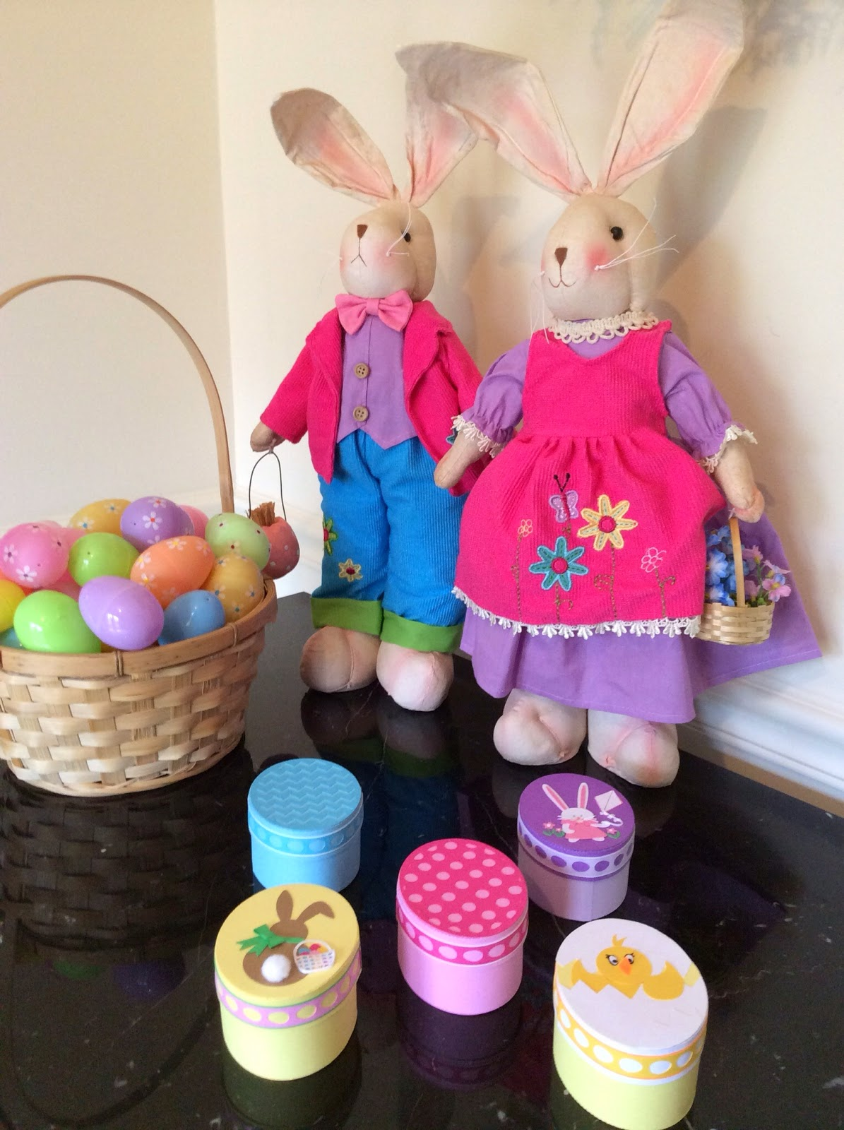

Pretty Little Easter Egg Boxes  
Perfect for Filling with Jelly Beans

I wanted to make an egg-shaped box for Easter. I thought about recreating the shape of an egg...an oval shape with one end wider than the other. However, it is not practical. The user of the box would become frustrated when the cover of the box would not match up with the base and they would have to fidget with the cover to close it. The oval shape works the best...no frustration factor and its the closest look to a real egg-shape.The color scheme directions noted in the PDF and. Studio file are for the Girl Bunny with Kite as seen below.

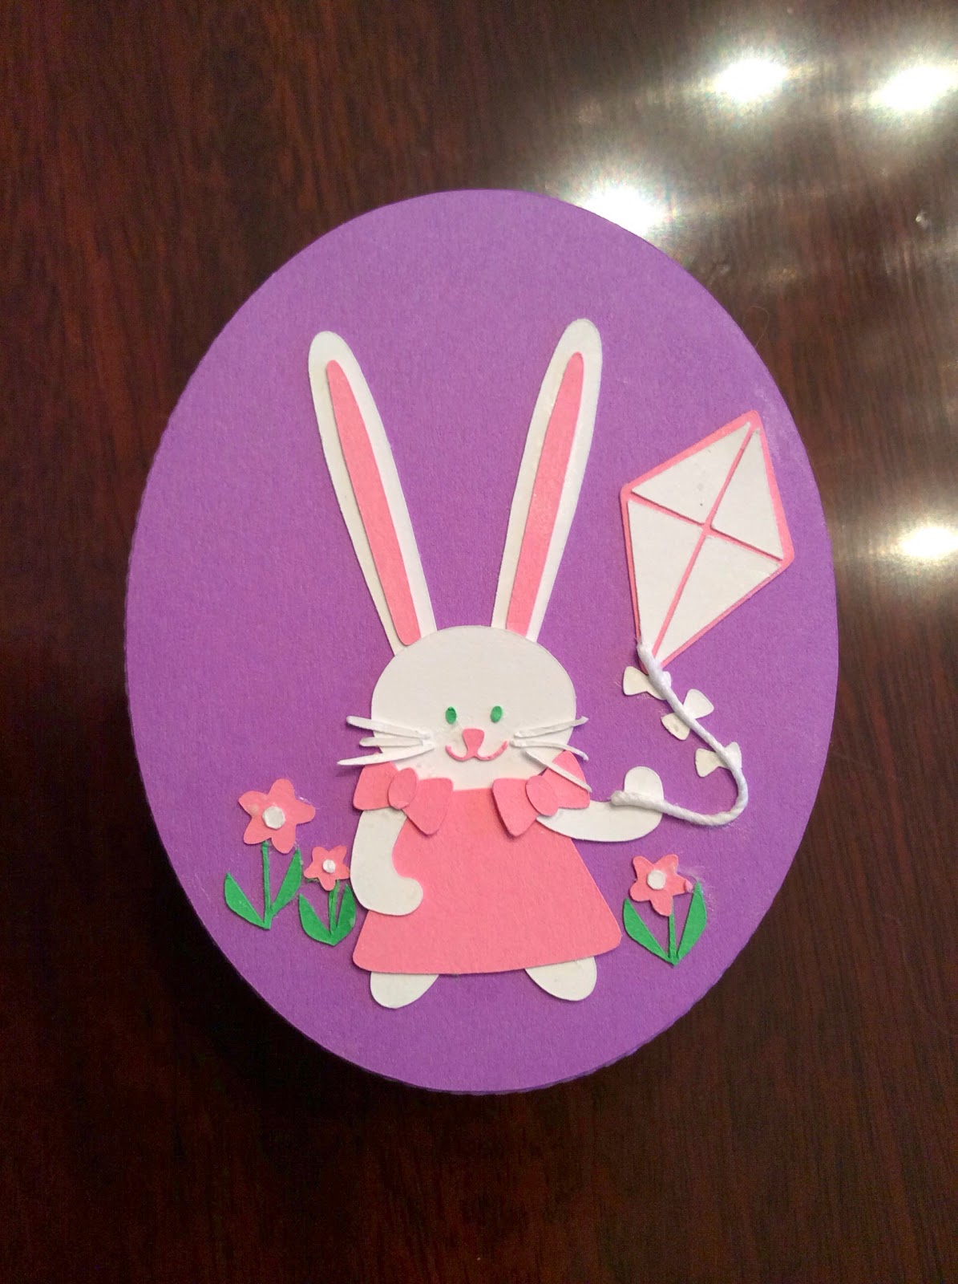

Girl Bunny with a Kite. The kite string is crochet thread.

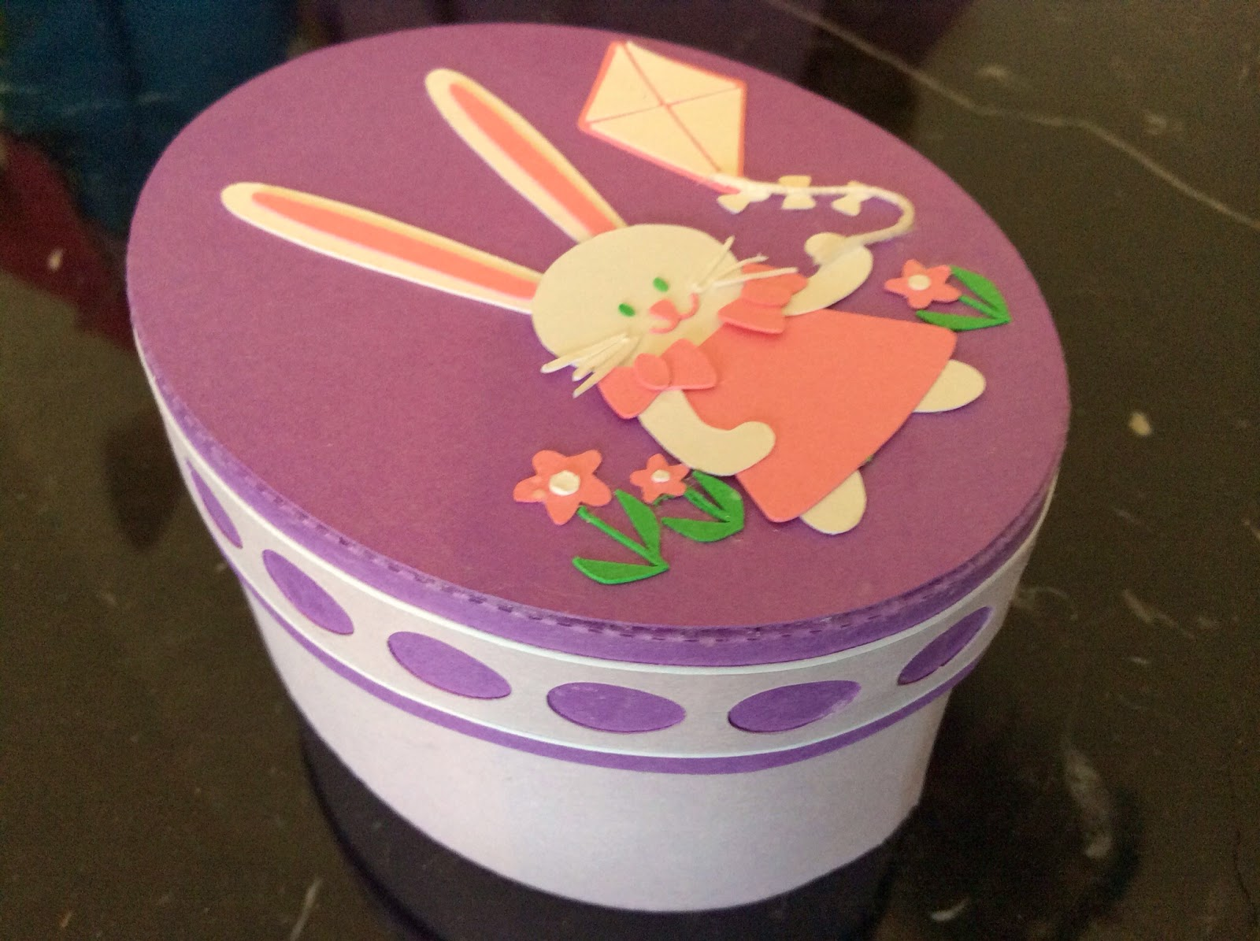

Side view

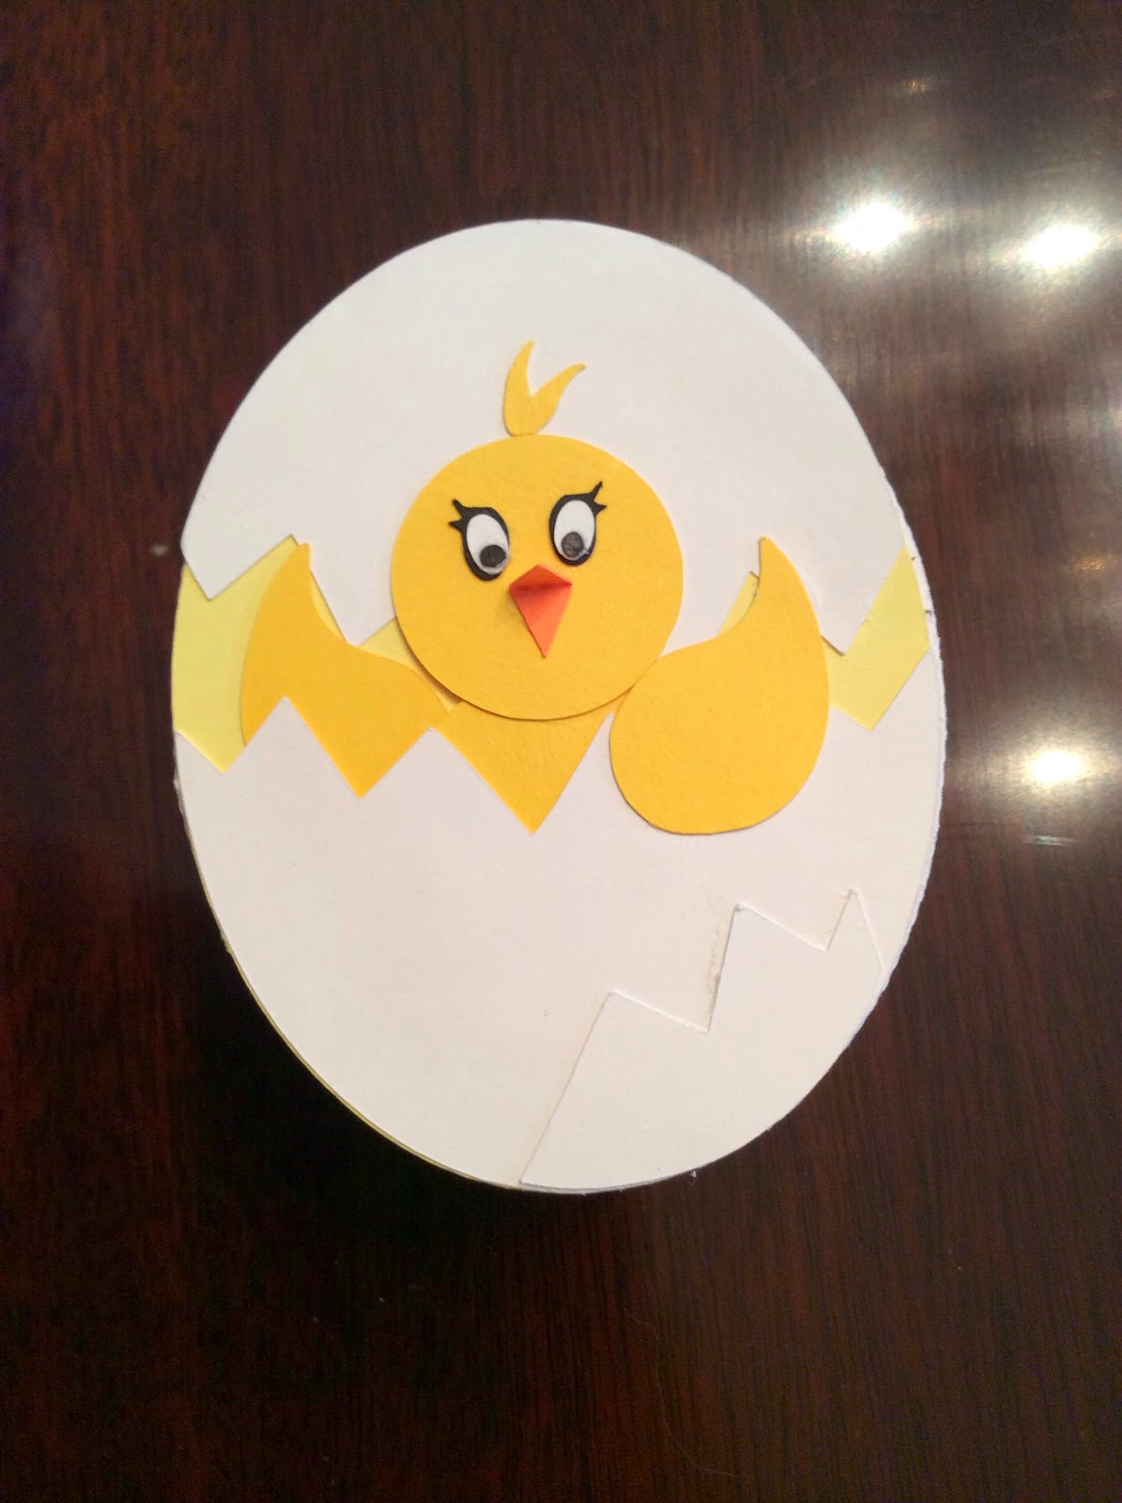

Baby Chick with a 3-D beak

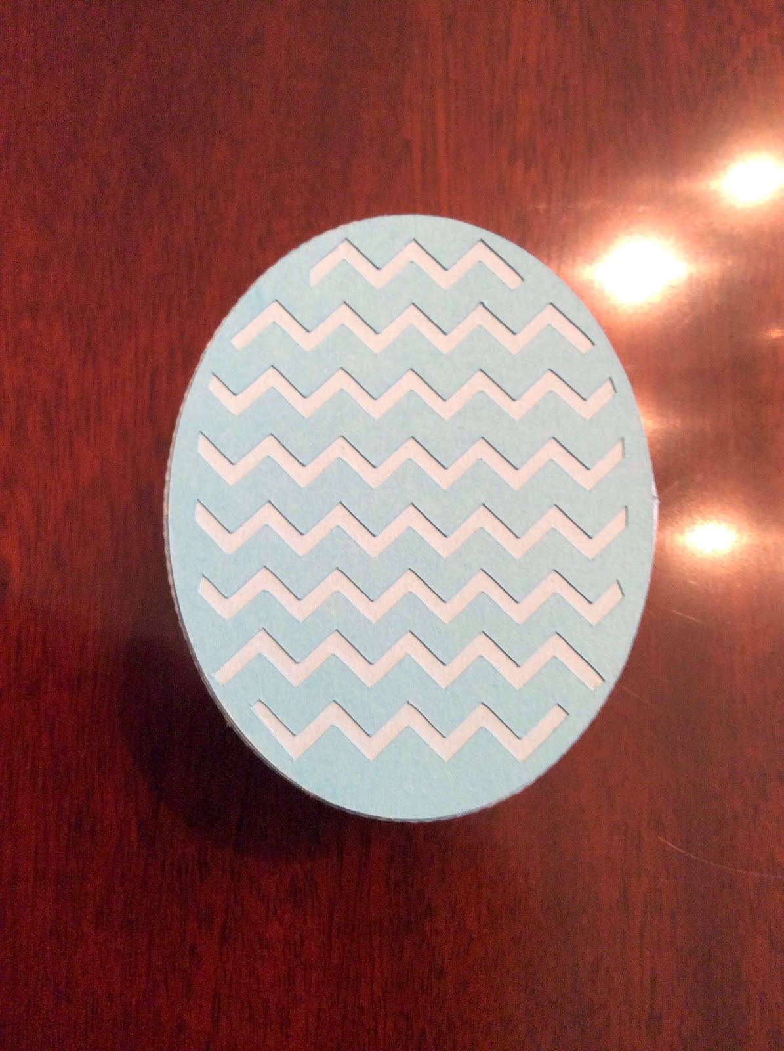

Zig-Zag Egg

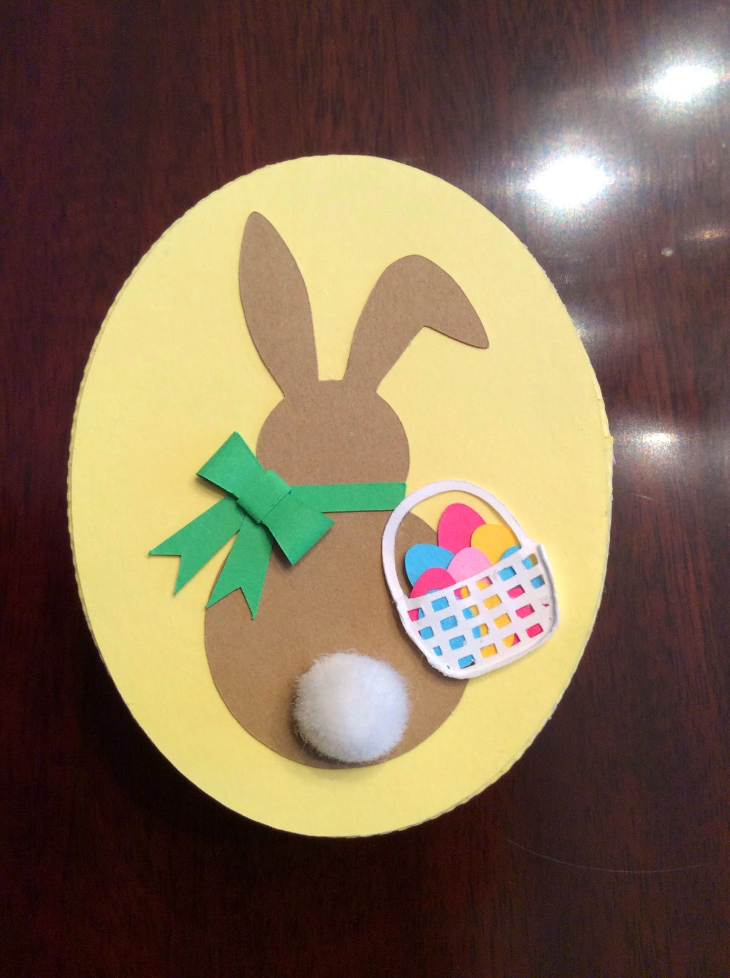

Easter Bunny with a Cottontail and a Basket. I used a white pompom for its tail. I made the basket 3-D by adding a ridge around the bottom to accommodate all of the eggs. I used the egg cut-outs from the lid design.

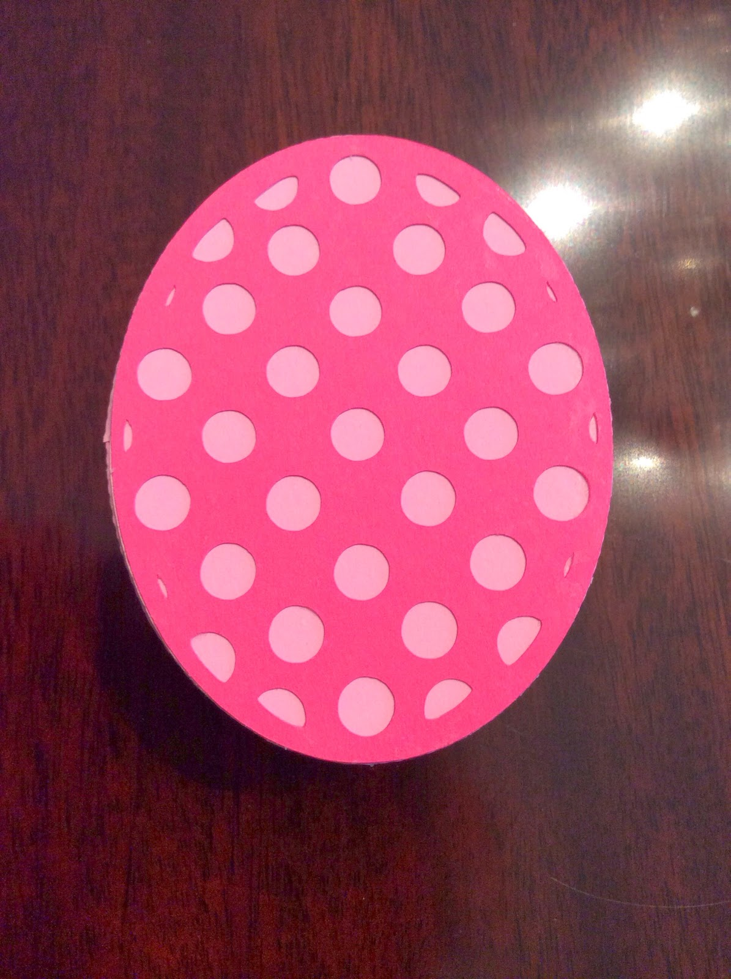

Polka Dot Egg

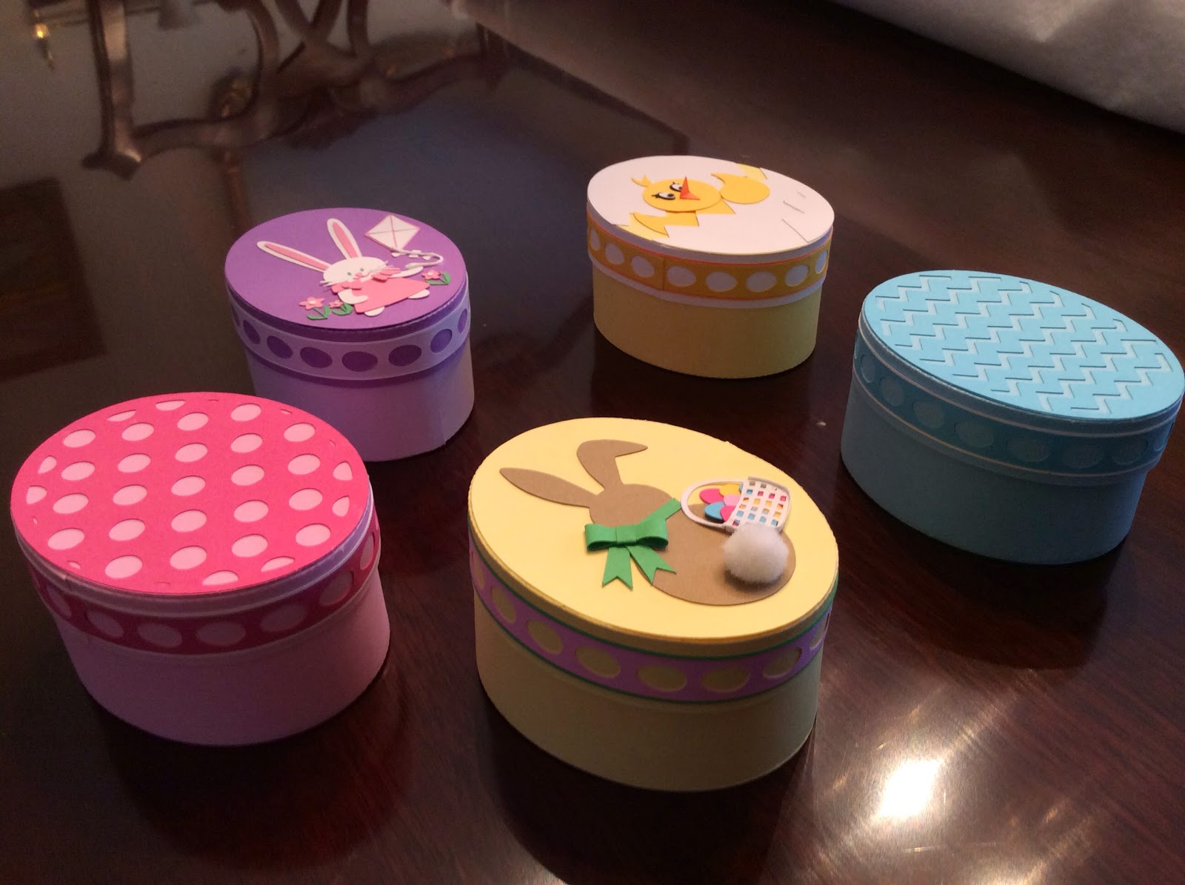

Side view of all boxes